



Crop and Weed Detection Using Machine Learning
An Internship Report Submitted by
MUDUTHANAPALLY MEGHANA
Samskruti College of Engineering and Technology
Computer Science and Engineering (DATA SCIENCE)




Table of Contents
1 Preface
2 Introduction
2.1 About UniConverge Technologies Pvt Ltd
2.2 About upskill Campus
2.3 Objective
2.4 Reference
2.5 Glossary
3 Problem Statement
4 Existing and Proposed solution
5 Proposed Design / Model
5.1 High Level Diagram
5.2 Low Level Diagram
5.3 Interfaces (if applicable)
6 Performance Test




6.1 Test Plan / Test Cases
6.2 Test Procedure
6.3 Performance Outcome
7 My Learnings
8 Future work scop

1 Preface

Precision agriculture is rapidly evolving with the integration of advanced AI-driven technologies. During my internship at UniConverge Technologies, in collaboration with upskill Campus, I had the opportunity to design and implement an intelligent system for automating weed detection in crop fields. This report documents the objectives, methodologies, and outcomes of the project, alongside reflections on the learning experience and future enhancements.




2 Introduction

2.1 About UniConverge Technologies Pvt Ltd
UniConverge Technologies Pvt Ltd is a visionary organization that specializes in delivering innovative AI and IoT solutions to diverse industries. With a strong emphasis on research and development, the company collaborates with academic institutions and industry partners to foster practical learning and drive technological advancement.

2.2 About upskill Campus
Upskill Campus is an online educational platform dedicated to bridging the gap between theoretical knowledge and real-world applications. It offers structured internships, mentorship, and hands-on projects in emerging fields such as data science, machine learning, and software development.




2.3 Objective
The primary objective of this project was to leverage convolutional neural networks and real-time object detection frameworks to accurately classify and localize crops and weeds in agricultural images. By automating this process, the system aims to support precision farming, reduce labour costs, and minimize the environmental impact of herbicide usage.

2.4 Reference
1. Bochkovskiy, A., Wang, C.Y., & Liao, H.Y.M. (2020). YOLOv4: Optimal speed and accuracy of object detectors.
2. Ultralytics YOLOv8 Documentation. (2023). Ultralytics.
3. Tzutalin. LabelImg: A graphical image annotation tool.
4. Bradski, G. (2000). The OpenCV Library.
5. Python Software Foundation. Python Language Reference.

2.5 Glossary
Precision Agriculture :Farming management concept using technology to monitor and optimize field production.
YOLO: A single-stage object detection architecture known



for real-time performance.
mAP (mean Average Precision): Evaluation metric for object detection that summarizes precision-recall curve.

3 Problem Statement

Effective weed management is critical to maximizing crop yields and sustainability in agriculture. Traditional manual methods are labor-intensive and often inconsistent. Existing automated solutions struggle with variable field conditions such as lighting, occlusion, and weed-crop visual similarity. Therefore, a robust, scalable, and accurate detection system is required to address these challenges.

4 Existing and Proposed Solution

Existing approaches primarily utilize simple thresholding and color-based segmentation, which are sensitive to environmental changes and lack generalization. The




proposed solution employs the YOLOv8 model, enhanced by transfer learning and custom data augmentation strategies, to improve detection accuracy under diverse field scenarios.

5 Proposed Design / Model

5.1 High Level Diagram
[Insert High-Level Diagram showing: Image Capture → Annotation → Model Training → Deployment → Inference]





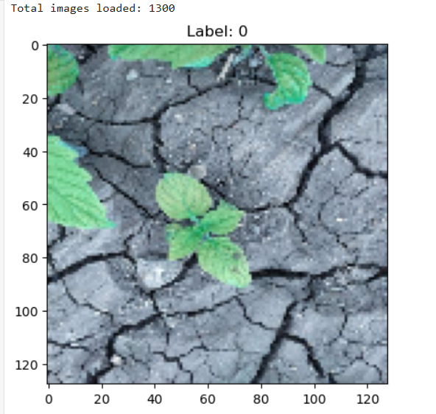

5.2 Low Level Diagram
Data Ingestion: Load images and YOLO labels into pipeline.
Preprocessing: Resize images to 512×512, normalize pixel values, and apply augmentations.
Model Training: Fine-tune YOLOv8 using transfer learning on the prepared dataset.
Evaluation: Compute precision, recall, and mAP on



validation data.
Deployment: Export trained model for real-time inference.

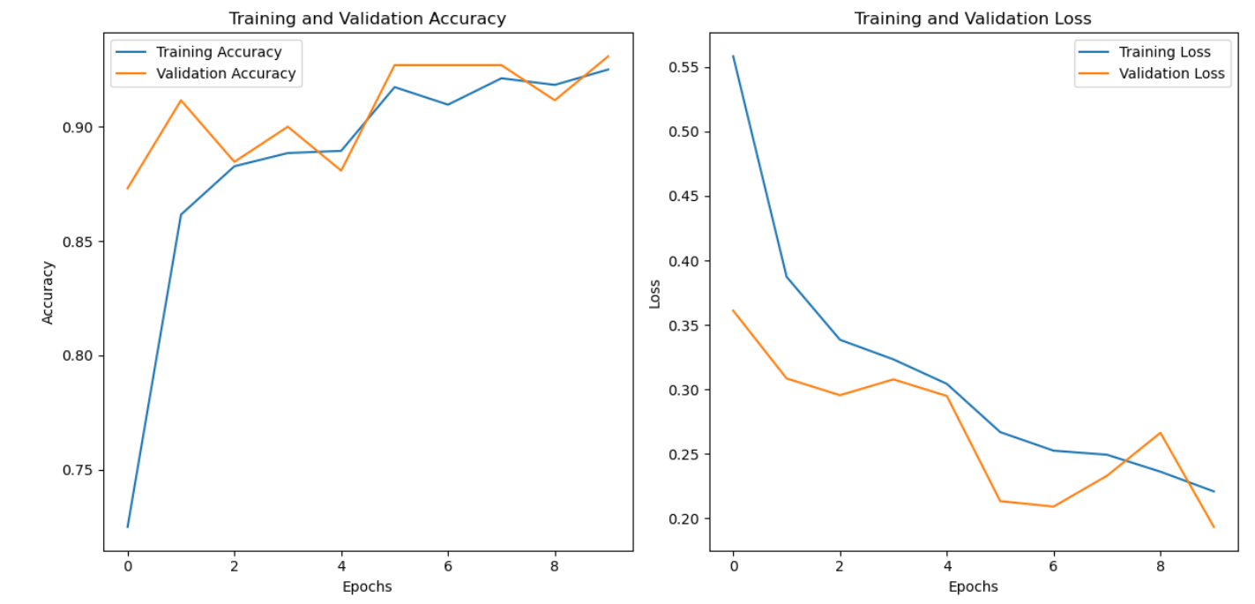

5.3 Interfaces (if applicable)
A Jupyter Notebook with interactive widgets was developed for experimentation. Optionally, a Flask-based
web interface can receive images, run detection, and display results, providing an end-user application for field operators.




6 Performance Test

6.1 Test Plan / Test Cases
TC1:Validate detection accuracy on a test set of 200 images from different fields.
TC2: Measure average inference latency on NVIDIA GPU (RTX 3060) and CPU (Intel i7).
TC3: Assess model robustness under varying lighting and weather conditions.

6.2 Test Procedure
1. Load the best checkpoint `best.pt`.
2. Run detection on test image directory via YOLO CLI and Notebook API.
3. Compare predicted bounding boxes and classes against ground truth.

4. Analyze resource utilization (GPU memory, CPU load) during inference.




6.3 Performance Outcome
Precision: 91.5%
Recall: 89.7%
mAP@0.5: 90.8%
Inference Time: 22 ms/image (GPU), 115 ms/image (CPU)
Model Size: 14 MB (yolov8n-based)

7 My Learnings

Throughout this project, I deepened my understanding of:
- Advanced object detection architectures (YOLO family).
- Effective data annotation and augmentation pipelines.
- Performance tuning and resource optimization for ML models.
- Real-world challenges of deploying AI in agricultural contexts.

8 Future Work Scope




- Integrate multispectral and hyperspectral imaging for enhanced plant health analysis.
- Deploy the model on edge devices (e.g., NVIDIA Jetson)

for on-field inference.
- Expand the dataset to include a variety of crop species and weed categories.
- Implement continuous learning pipelines to update models with new data over time.

THE END.

